SOURCE CODE

import java.util.Objects;  
import java.util.Scanner;  
  
public class Main {  
 public static int regularWorkingHours = 120;  
  
 static double HourlyRate(String empStatus) {  
 double hourlyRate = 0;  
 if (Objects.equals(empStatus, "entry level")) {  
 hourlyRate = 850.0 / 8;  
 } else if (Objects.equals(empStatus, "managerial level")){  
 hourlyRate = 1150.0 / 8;  
 }  
 return hourlyRate;  
 }  
  
 static double Basic (int totalWorkingHours, double ratePerHour){  
 if ( totalWorkingHours > regularWorkingHours )  
 return (regularWorkingHours \* ratePerHour);  
 else  
 return (totalWorkingHours \* ratePerHour);  
 }  
  
 static double OvertimePay(int totalHoursWork, double ratePerHour){  
 double overtimePay = 0;  
 if (totalHoursWork > regularWorkingHours) {  
 overtimePay = ((1.5 \* ratePerHour) \* (totalHoursWork - regularWorkingHours));  
 overtimePay \*= .10;  
 }  
 return overtimePay;  
 }  
  
 public static void main (String[] args) {  
 int hoursWork, absences, totalWorkHours;  
 int SSS = 500, PhilHealth = 300, pagIbig = 350;  
 double basicSalary, finalSalary, deduction, grossIncome,bonus = 0, ratePerHour, otPay;  
 double tax = 0.10;  
 String employeeStatus = "";  
  
 Scanner scan = new Scanner(System.in);  
 System.out.print("Enter total hours work: ");  
 hoursWork = scan.nextInt();  
 scan.nextLine();  
 System.out.print("Enter employee status: ");  
 employeeStatus = scan.nextLine();  
 System.out.print("Enter absent: ");  
 absences = scan.nextInt();  
 scan.close();  
  
 totalWorkHours =hoursWork - absences;  
 ratePerHour = HourlyRate(employeeStatus);  
 otPay = OvertimePay(totalWorkHours,ratePerHour);  
 basicSalary = Basic(totalWorkHours, ratePerHour);  
 grossIncome = basicSalary + otPay;  
 deduction = SSS + PhilHealth + pagIbig + (grossIncome \* tax);  
  
 if(absences == 0) {  
 bonus = grossIncome \* 0.2;  
 finalSalary = (grossIncome - deduction) + bonus;  
 } else {  
 finalSalary = grossIncome - deduction;  
 }  
  
 System.out.println("\n----------------------------------------");  
 System.out.println("Employee's Position: " + employeeStatus);  
 System.out.println("Gross Salary: " + grossIncome);  
 System.out.println("Absent: " + absences);  
 System.out.println("Bonus: " + bonus);  
 System.out.println("Deduction: -" + deduction);  
 System.out.println("final Salary: " + finalSalary);  
  
 }  
}

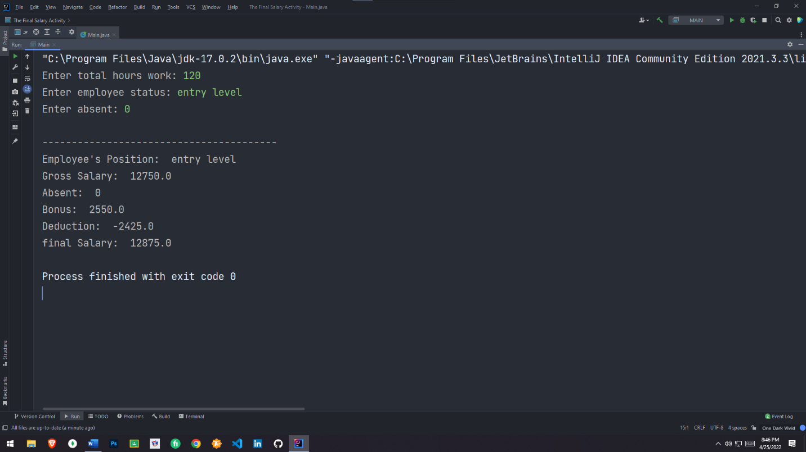OUTPUT